

A TECHNICAL REPORT ON

**STUDENT’S INDUSTRIAL WORK EXPERIENCE SCHEME (SIWES)**

**UNDERTAKEN AT:**

**NATIONAL CENTRE FOR GENETIC RESOURCES AND BIOTECHNOLOGY**

**(NACGRAB) APATA, IBADAN, OYO STATE.**

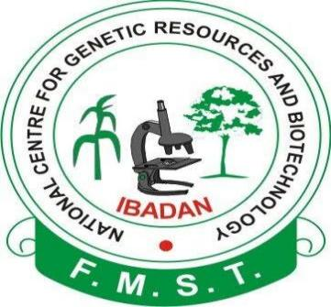

**BY**

**ADEDAYO, ISAAC TAIWO.**

**BTH/18/7950**

SUBMITTED

TO

THE

DEPARTMENT OF BIOTECHNOLOGY,

FEDERAL UNIVERSITY OF TECHNOLOGY AKURE, ONDO STATE,NIGERIA.

IN PARTIAL FULFILMENT FOR THE AWARD OF BACHELOR OF TECHNOLOGY(B.TECH.) BIOTECHNOLOGY

FEBUARY 2024

# CERTIFICATION

This is to certify that this report was written by ADEDAYO, ISAAC TAIWO, Matriculation Number BTH/18/7950 of the Department of Biotechnology, Federal University of Technology Akure, on the Industrial Training carryout at NACGRAB for the period of four months.

________________________ ________________________

Student’s Signature/Date Supervisor’s Signature/Date

____________________________

Head of Department’s Signature/Date

## DEDICATION

This report is dedicated to all the individuals who have contributed their time, effort, and expertise to the advancement of industrial innovation.

To the pioneers and visionaries who continuously push the boundaries of what is possible, this dedication honors your unwavering commitment to progress and excellence.

To the diligent engineers, technicians, and workers who labor tirelessly behind the scenes, this dedication recognizes your dedication and invaluable contributions to the industrial landscape.

To the mentors and leaders who inspire and guide the next generation of industrial professionals, this dedication expresses gratitude for your wisdom, mentor ship, and support.

May this report serve as a tribute to the collective efforts of all those who strive to make a meaningful impact in the industrial sector, shaping a brighter future for generations to come.

# 

# ACKNOWLEDGEMET

This report is dedicated to all the individuals who have contributed their time, effort, and expertise to the advancement of industrial innovation.

To the pioneers and visionaries who continuously push the boundaries of what is possible, this dedication honors your unwavering commitment to progress and excellence.

To the diligent engineers, technicians, and workers who labor tirelessly behind the scenes, this dedication recognizes your dedication and invaluable contributions to the industrial landscape.

To the mentors and leaders who inspire and guide the next generation of industrial professionals, this dedication expresses gratitude for your wisdom, mentor ship, and support.

May this report serve as a tribute to the collective efforts of all those who strive to make a meaningful impact in the industrial sector, shaping a brighter future for generations to come.

## ABSTRACT

This report presents a comparative analysis of the practical experiences gained during the Student Industrial Work Experience Scheme (SIWES) in Plant Tissue Culture and Molecular Biology Laboratories, within the field of Biotechnology. The objective was to elucidate the practical applications of theoretical knowledge in these specialized laboratory settings.

The report begins with an overview of the role and significance of Plant Tissue Culture and Molecular Biology techniques in contemporary Biotechnology research and development. The theoretical foundations underpinning these techniques are discussed, setting the stage for the practical insights gained during the SIWES period.

Detailed descriptions of the tasks and responsibilities undertaken in both laboratories are provided, encompassing a range of techniques such as tissue culture propagation, media preparation, DNA extraction, PCR amplification, gel electrophoresis, and genetic analysis. Emphasis is placed on hands-on experimentation, data interpretation, and troubleshooting encountered during these procedures.

Furthermore, the methodologies employed in each laboratory setting are critically evaluated, highlighting the equipment, reagents, and protocols utilized. Practical challenges encountered, including contamination issues, technical errors, and experimental limitations, are discussed alongside the strategies employed to address them.

The report also reflects on the integration of soft skills such as communication, teamwork, and time management, essential for effective laboratory practices and collaboration within multidisciplinary research teams.

In conclusion, this report underscores the invaluable role of experiential learning in Biotechnology education, bridging the gap between theoretical knowledge and practical application. The insights gained from the SIWES experience in Plant Tissue Culture and Molecular Biology laboratories contribute to the holistic development of future biotechnologists, preparing them for the dynamic challenges of the industry.

窗体顶端

窗体底端

## **TABLE OF CONTENTS**

### CERTIFICATION ……………………………………………………………..……2

### DEDICATION ………………………………………………………………………..3

### ACKNOWLEDGEMENT …………………………………………………………...4

### ABSTRACT …………………………………………………………………………..5

### TABLE OF CONTENTS …………………………………………………………….7

### CHAPTER ONE ………………………………………………………………….….13

### 1.0 INTRODUCTION TO SIWES …………………………………………….…….13

### 1.1 BACKGROUND …………………………………………………………..……..13

### 1.2 BRIEF HISTROY ON SIWES ……………………………………………...……13

## 1.3 AIM AND OBJECTIVES OF SIWES ……………………………………………..14

### CAPTER TWO ……………………………………………………………………..…15

2.0 NATIONAL CENTRE FOR GENETIC RESOURSES AND BIOTECHNOLOGY (NACGRAB)…………………………………………………………………………..15

## 2.1 OVERVIEW OF NATIONAL CENTRE FOR GENETIC RESOURSES AND BIOTECNOLOGY……………………………………………………………………..16

## 2.2 OBJECTIVES OF NACGRAB……………………………………………………16

2.3 NACGRAB RESEARCH MANDATE……………………………………………16

## 2.4 BRIEF DISCUSSION ON THE ECONOMIC ENVIRONMENT IN WHICH NACGRAB OPERATE……………………………………………………………….17

## 2.5 MANAGEMENT STRUCTURE OF NACGRAB……………………………….18

## 2.6 VARIOUS UNIT IN NACGRAB AND THEIR FUNCTION……………………19

# CHAPTER THREE…………………………………………………………………….20

## 3.0 EXPERIENCE GAINED AT NACGRAB…………………………………………20

3.1 PLANT TISSUE CULTURE LABORATORY…………………………………..20

## 3.1.1 GLASSWARE PREPARATION……………………………………………….2O

## 3.1.2 MEDIA PREPARATION………………………………………………………22

## 3.1.3 EXPLANT COLLECTION AND STERILIZATION………………………….24

## 3.1.4 CULTURING AND SUBCULTURING……………………………………….24

## 3.1.5 ACCLIMATIZATION…………………………………………………………25

## 3.2 MOLECULAR BIOLOGY LABORATORY……………………………………..29

3.2.1 INTRODUCTION AND APPLICATION OF MOLECULAR BIOLOGY…29

3.2.2 INSTRUMENTATION IN MOLECULAR LABORATORY………………29

3.2.3 REAGENT PREPARATION………………………………………………..35

## 3.2.4 DNA EXTRACTION AND QUANTIFICATION…………………………………37

## 3.2.5 POLYMERASE CHAIN REACTION…………………………………………..40 3.2.6 ELECTROPHORESIS…………………………………………………………..42

# CHAPTER FOUR………………………………………………………………….……..45

# 4.0 CONCLUSION AND RECOMMENDATION…………………………….………45

## 4.1 CONCLUSION…………………………………………………………………….…45

## 4.2 RECOMMENDATION………………………………………………………………45

# REFRENCES………………………………………………………………………..…..46

# LIST OF FIGURES

# LIST OF PLATES

# LIST OF TABLES

## 

## 

### 

# CHAPTER ONE

# 1.0 INTRODUCTION TO SIWES PROGRAM

# 1.1 BACKGROUND

The student industrial work experience scheme [SIWES] is an integral part of a degree and diploma program in an institution of higher learning in Nigeria. It is designed to take place outside the school to expose the student to practical work experience on their field of study during the period of training. This industrial training policy was introduced by the Federal Government of Nigeria in 1973 and is strategized for skills acquisition by students useful in their various fields of learning. This skill training program has been initiated to complement the theoretical knowledge acquired in tertiary institutions with practical experience as well as expose and prepare students for the industrial work situation they are likely to meet after graduation. The duration of this training varies depending on the tertiary institution and is always ranging from three (3) to six (6) months for universities and a year for colleges and polytechnics. This internship program can therefore be seen as that which is intended to give Nigerian students studying occupationally related courses experience that would supplement their theoretical learning as a way of equipping the students with the needed skills to function in the world of work. Therefore, SIWES is a key factor required to inject and help keep alive industrialization and economic development in the nation through the introduction and practical teaching of scientific and technological skills to students and also in partial fulfilment of the award of Bachelor of Science or Bachelor of Technology as the case may be.

# 1.2 BRIEF HISTORY OF SIWES

At the early stages of the development of education in Nigeria, there was a problem of the gap between theory and practical skills of student. So as a means of bridging the gap between theoretical and practical knowledge, the Industrial Training Fund (which was itself established in 1971 by decree 47) initiated the student Industrial Work Experience Scheme (SIWES) in 1973. The ITF solely funded the scheme during its formative years i.e. (1973/1974). But as the financial involvement became unbearable to the fund, it withdrew from the scheme in 1978. The Federal government handed over the scheme in 1979 to both the National Universities Commission (NUC) and the National Board for Technical Universities Education (NBTE). Later the Federal Government in November 1984 reverted the management and implementation of the scheme to ITF and it was effectively taken over by the Industrial Training Fund in July 1985 with the funding being solely borne by the government. The scheme has been designed to expose students of tertiary institutions to the Industrial environment and enable them develop occupational competencies so that they can readily contribute their quota to national economic and technological development after graduation.

# 1.3 AIM AND OBJECTIVES OF SIWES

The Industrial Training Fund’s policy which established SIWES outlined the following as the objectives of the scheme:

* To expose students to work methods and techniques that may not be available during their course of study
* Bridging the gap between theory and practical by providing a platform to apply knowledge learnt in school to real work situations
* Enabling the easier and smoother transition from school by equipping students with better contract for future work placement
* To teach students the techniques and methods of working with facilities and equipment’s that may not be available within the walls of an educational institutions
* To introduce students to real work atmosphere so that they know what they would most likely meet once they graduate
* To create conditions and circumstances which can be close as possible to the actual workflow
* To prepare specialists who will be ready for any working situations immediately after graduation
* To expose students in tertiary institutions in Nigeria to latest technologies, thereby preserving the technological prowess of the country.

# 

# CHAPTER TWO

# 2.0 NATIONAL CENTER FOR GENETIC RESOURSES AND BIOTECHNOLOGY.

# 2.1 OVERVIEW OF NACGRAB

National Centre for Genetic Resources and Biotechnology (NACGRAB) was established in 1987 by the Federal Ministry of Science and Technology (FMS&T) in other to conduct research, gather data and disseminate technological information on matters relating to genetic resources conservation, utilization and biotechnology applications. The Centre, backed by Decree 33 of 1987 regulates the seed, livestock and fisheries industries through its Varietal Release Committees.

In January, 2004 the Center was up-graded to the status of a parastatal. However, during the reorganization of parastatal and agencies under the Federal Ministry of Science and Technology in 2007, NACGRAB was merged with National Biotechnology Development Agency (NABDA), NACGRAB through its various programme, has continued to contribute significantly to the conservation of the rich genetic resources of the nation.

The National Centre for Genetic Resources and Biotechnology is located at NCRI, Moor Plantation, Ibadan/Abeokuta road, Apata, Ibadan, Oyo State.

**2.2 OBJECTIVES OF NACGRAB**

* Development of animal genetic resources (poultry, snailry, fisheries etc).
* Application of tissue culture for plant conservation and overall agricultural development;
* Servicing of the activities of the National Committee on Naming, Registration and Release of Crops Varieties, Livestock Breed and Fisheries;
* Networking and coordinating activities in the development of capacities in plant and animal genetic resources.

**VISION**

A Centre that is committed to the conservation of the rich Genetic Resources of the nation, with a view to enhancing agricultural, economic and social development.

**MISSION**

Nigeria is endowed with diverse biological heritage, which needs to be maintained for the purpose of utilization and for posterity. NACGRAB is to ensure the conservation and sustainable use of these rich biodiversity through Research and Development.

**2.3 NACGRAB RESEARCH MANDATE**

National Center for Genetic Resources and Biotechnology in Nigeria market renders the following services via its mandate;

* Exploration, collection, identification, evaluation, characterization, storage and conservation of rich stock of both animal and plant germplasm material.
* National coordination of genetic resources programme and its sustainable utilization.
* Fostering relationship with other national satellites genetic research centres located in research institutes, universities and polytechnics as well as the international organizations and centres of programmes concerning genetic resources and biotechnology application.
* Arrest rapid erosion and loss in the country’s crop and animal genetic resources caused by cultivation, urbanization rural development, desertification, national catastrophes etc.
* Documentation appropriately the germplasm stocks held by the center, research institutes and relevant organizations.

**2.4 BRIEF DISCUSSION ON THE ECONOMIC ENVIRONMENT IN WHICH NACGRAB OPERATES.**

NACGRAB'S programmes cut across several sectors under Nigeria economic environment ranging from Science and Technology Development down to Agricultural production and Food Security. To execute the mandate effectively and ensure proper running of activities within the organization, NACGRAB collaborate with indigenous and international research institute, universities and biotechnological companies abroad (Ingaba biotechnology] considering the location of NACGRAB, it is not the only research in the area. Other research institute that are few kilometers away include: National institute of horticultural research [NIHORT] institute of agricultural research and training [IAR & T] liaison with other relevant international organization e.g. international plant genetic research institute [IPGRI], food and agricultural organization [FAO] and the international institute of tropical agriculture [IITA]

**2.5. MANAGEMENT STRUCTURE OF NATIONAL CENTER FOR GENETIC RESOURCES AND BIOTECHNOLOGY**.

NACGRAB is headed by a Director/Chief Executive Officer (CEO). He is responsible for daily operations at the Center. He also oversee the activities of various units at the Center.

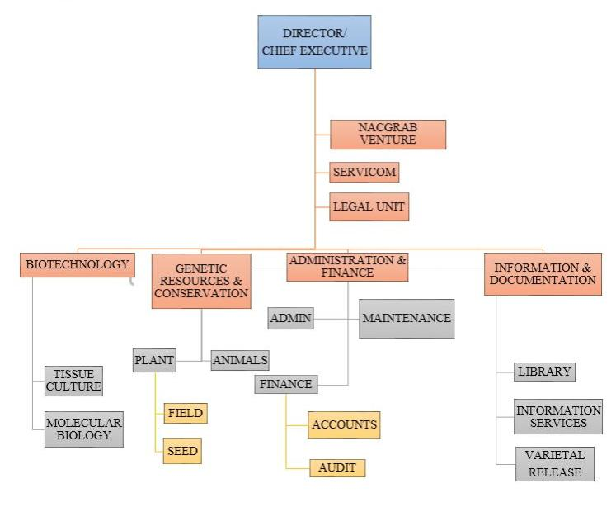

Fig 1: Organizational chart of NACGRAB

**2.6. Various units in NACGRAB and their functions**

The Center has a total of seven (7) units namely: Plant Genetic Resources (PGR), Animal Genetic Resources (AGR), Biotechnology, Administration, Accounts, Information and Documentation, each unit has a head who oversees/coordinates the operations of the unit and in turn reports directly to the Director/CEO.

Animal genetic resources

AGR unit of NACGRAB is one of the core Units of the Centre established in the year 2004 and currently has the following sections: poultry, fishery, snailry, small ruminants, cane-rat and rabbitry.

The functions of the Unit include the following:

-      Exploration, collection and conservation of various indigenous animal genetic resources

-      Preservation of endangered animal genetic resources

-      Genetic characterization and evaluation of animal genetic resources in Nigeria

-      Conduct research in conservation and utilization of animal genetic resources including the use biotechnology tools

-      Assist National Varietal Release Committee (NVRC) in the Livestock breeds and Fisheries strains Naming, Registration and Release Activities.

Biotechnology unit

Biotechnology harnesses cellular and bio-molecular process to develop solution that helped solve problems in many areas including agriculture and environment. The biotech unit of the centre was established in 1999 to handle issues relating to research and development of genetic resources, in other to complement the conservation mandate of the Centre using simple biotechnology tool.

The unit is divided into sub units: Plant tissue culture section and Molecular biology section.

Tissue culture: This section mostly supports the mandate of the Centre. Tissue culture unit engaged mainly in in-vitro conservation, regeneration and multiplication of both agronomic and tree crop species, on a nutritional medium under an aseptic environmental condition. The Tissue culture laboratory housed some certain important sections which are: Growth room/Transfer section, Media preparatory room, washing and storage room, screen house, post flask and the TIBS (Temporary Immersion Bioreactor System).

Molecular Biology Laboratory: This section helps in characterization and evaluation of plant and animal genetic resources in the country. Also molecular characterization and fingerprinting of germplasm collections using molecular makers approach for identification, reduction of vast collections to their genetic variants and construction of fine phylogenetic trees etc.

# CHAPTER THREE

# 3.0 EXPERIENCE GAINED AT NACGRAB

3.1 PLANT TISSUE CULTURE LABORATORY

Plant tissue culture laboratories stand as modern marvels in the realm of botanical sciences, fostering the cultivation and manipulation of plant cells under controlled conditions. Through this technique, scientists can propagate, manipulate, and genetically modify plants with precision, revolutionizing agriculture, horticulture, and even pharmaceutical industries.

In these laboratories, aseptic techniques reign supreme, ensuring the sterility of the environment and preventing contamination. Specialized equipment such as laminar flow hoods, autoclaves, and incubators create the ideal conditions for plant tissue growth. Nutrient media, carefully formulated with precise combinations of minerals, vitamins, and growth regulators, nourish the plant tissues and promote their proliferation.

The applications of plant tissue culture are vast and diverse. It enables the mass production of disease-free plants, the preservation of rare and endangered species, and the rapid multiplication of elite crop varieties. Moreover, it serves as a platform for genetic engineering, allowing the introduction of desirable traits such as pest resistance, drought tolerance, and enhanced nutritional content into plants.

Reference: Smith, R.H. (2013). Plant Tissue Culture: Techniques and Experiments (3rd ed.). Academic Press.

3.1.1 GLASSWARE PREPARATION

Glassware preparation in plant tissue culture is a critical aspect to ensure the success of experiments and the maintenance of sterile conditions. Here's an overview of the steps involved:

Cleaning: All glassware must be thoroughly cleaned to remove any contaminants. This typically involves washing with detergent, rinsing with water, followed by rinsing with deionized water or distilled water to prevent mineral deposits.

Sterilization: After cleaning, glassware needs to be sterilized to eliminate any remaining microorganisms. This is commonly done using autoclaving, where the glassware is subjected to high-pressure steam at temperatures around 121°C (250°F) for a specified period, typically 15-30 minutes. Autoclaving effectively kills bacteria, fungi, and other microorganisms.

Drying: Once sterilized, it's essential to ensure that the glassware remains dry until it's ready for use. Sterile glassware is typically dried in a laminar flow hood or a clean environment to prevent recontamination.

Assembly in aseptic conditions: After drying, the glassware should be assembled in a sterile environment, such as a laminar flow hood. Care should be taken to avoid touching the interior surfaces of the glassware to prevent contamination.

Storage: Sterile glassware can be stored in a clean, dry environment such as growth room until they are needed. It's important to store the glassware in a way that prevents dust or other contaminants from settling on it.

Quality control: Regular checks should be performed to ensure that the sterilization process is effective and that the glassware remains free of contaminants. This can involve periodic testing for sterility and visual inspections for any signs of damage or contamination.

By following these steps, plant tissue culture laboratories can ensure that their glassware remains sterile and suitable for use in experiments, contributing to the success and reliability of their research.

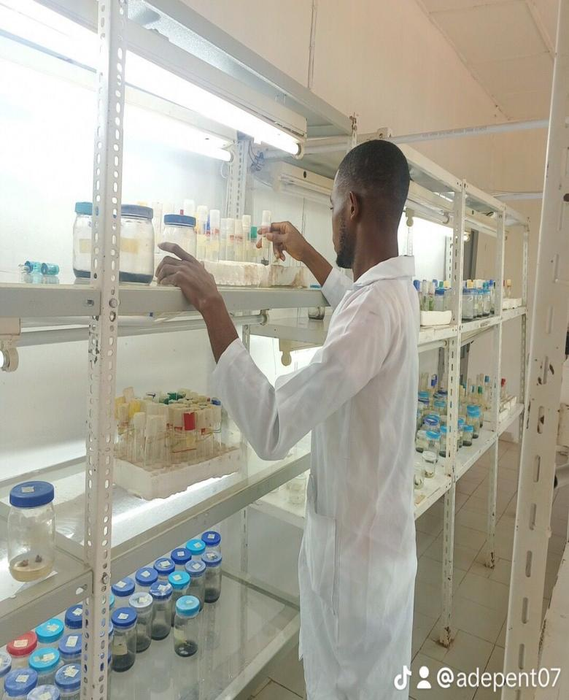

PLATE 3.0.1 PLACING OF STERILIZED TEST TUBE IN THE GROWTH ROOM.

# 3.1.2 MEDIA PREPARATION

Procedure for preparation of yam regeneration media

1. Media preparatory room was disinfected using 70% ethanol.
2. Distilled water was made available and ions present in the water was removed by using water deionizer.
3. A known volume of deionized water was added into a beaker and placed on magnetic stirrer with the magnetic bar in the beaker.
4. The various media constituents (Macro and Micro nutrients, Iron, EDTA, Carbon source etc) was weighed and poured into the beaker respectively.
5. After the constituents have been added, the pH electrode was dipped inside the media to determine the pH of the media (5.7).

**Note:** If the pH was below 5.7-5.8, NaOH a base would have been added to increase the PH. While, if the pH was above 5.7-5.8, HCL an acid would have been added to reduce the PH.

1. Agar was added and melted using microwave.
2. Using a syringe, 50ml of the media was dispensed each into test tubes.
3. Media was sterilized using autoclave for 15 minutes before being stored in the growth room till ready to be used.

What is media

It is a nutritional medium prepared in standard concentration to enhance the growth and development of plants.

Types of media

* MS – Murashige and Skoog (1962)
* WPM – Woody Plant Medai
* VGA – Vitamins and Gibberllic Acid etc.

Basic constituent of media

1. Macro nutrients (stock 1)
2. Micro nutrients (stock 2)
3. Iron and EDTA (stock 3)
4. Vitamins (stock 4)
5. Carbon source
6. Plant growth regulator (PGR)
7. Gelling agent/solidifier
8. Activated charcoal (optional).

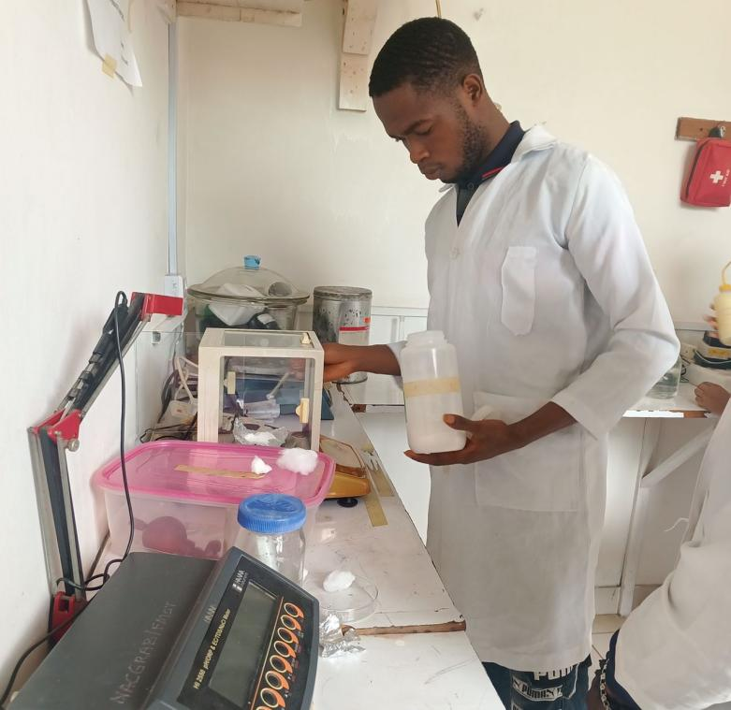

PLATE 3.2 MEASURING OF MEDIA CONSTITUENTS USING ANALYTICAL BALANCE.

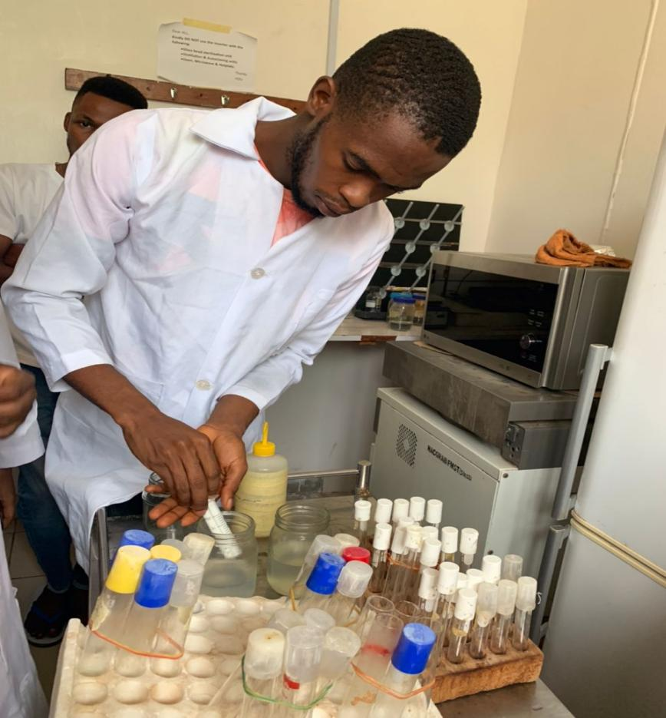

PLATE 3.3 TRANSFERING OF MEDIA INTO TEST TUBES.

3.1.3 EXPLANT COLLECTION AND DISINFECTION

Collection of vegetative part of plants was from field gene bank. **Note;** ex-plants are best collected from the meristematic part of the plant ie the actively dividing part.

Disinfection procedure

* Ex-plant was washed thoroughly under running water using liquid soap to eliminate surface dirt and thrice rinsed with distilled water after which it was soaked with 70% ethanol for 5 minutes and thrice rinsed with distilled water
* After that, explant was soaked with sodium hypochlorite for 10 minutes and thrice rinsed with distilled water.
* Ex-plant was finally placed on a sterile petri dish and transferred to the culture room for inoculation.

3.1.4 CULTURING AND SUBCULTURING

Inoculation/culturing

This is the transfer of the ex-plant to a culture medium.

**Procedure in culturing**

* Laminar flow hood was switched ON and disinfected using 70% ethanol and swabbed with cotton wool.
* Two petri dishes containing 70% ethanol was set.
* Culture vessel containing the already sterile prepared media was arrange neatly inside the flow hood and sprayed with 70% ethanol.
* Hands were disinfected with 70% ethanol.
* Spirit lamp was lit, forceps flamed and allowed to cool.
* Explants were excised using sterilized petri-dish, forcep and blade suspended in a blade holder.
* Explants were inoculated into the media and transferred to the growth room for regeneration.
* Working area was cleaned and flow hood switched off.

**Sub-culturing**

This involved transferring the regenerated plantlet from its previous media into a new media which could be proliferation media.

**Types of Sub-culturing**

* Nodal cutting for yam

Pineapple stem subculture

**Acclimatization/post flask management**

Post Flask Management

Post flask Management is a technique which involves acclimatization, hardening or weaning of tissue cultured plantlets after they are removed from culture container until finally established on the field. This is an intermediate stage (transition) between the culture containers and the field.

Post flask management technique can be described under five main stages:

1. **Plantlets preparation:** Plantlets to be acclimatized must have well defined shoots and roots. It must be free from any forms of mechanical damage and contamination.
2. **Safe handling of plantlets:** Tissue culture plantlets are very tender, fragile and sensitive to shock. Therefore optimal care is required in handling it, to prevent damage prior transplanting.
3. **Preparation of transplanting kits:** The materials /medium used for transplanting must be sterile to prevent contaminations, medium must be in the right proportions.
4. **Transplanting:** Plantlets are labeled with plastic tags prior to its removal from the culture Vials. The plantlets removed are washed in a container of water in other to wash off the media on the roots to discourage microbial growth. The roots are immersed completely and covered with sterile soil medium then kept inside a white polythene bag, watered, tied properly and then kept inside acclimatization chamber to avoid wilting due to possible evapo-transpiration in the outside environment.
5. **Releasing of humidity chamber:** The TC plantlets are kept in the acclimatization chamber for an average of one to two weeks before chamber is opened to release the humidity. The length of period at which plantlets are retained in the chamber depend largely on the performance of plantlets.
6. **Potting/ Field establishment:** When plantlets has fully acclimatized, they then undergo a stage of weaning called potting” whereby soil compositions are prepared and potted in black polythene bags prior potting of plantlets. And when the plantlet has fully developed to seedlings it’s then transferred to the field for establishment.

**Importance/Advantages of Post flask Management to Tissue culture Plantlets.**

* To create high level of humidity for the survival of in vitro plantlets.
* It’s a transition stage that enhances gradual adaptation of plantlets from in vitro to ex vitro condition.
* It’s prevents plantlets from abiotic stress (low humidity, direct sunlight, wind, heavy rain drops).
* To prevent dehydration of plantlets in an in vitro condition.
* To provide an absolute establishment of 100% survival of the plantlets for field establishment.

**NOTE:** Certain things are usually looked into during the process or stage of acclimatization. For instance;

**The soil used must have the following components;**

* Top soil.
* Stone dust or river sand.
* Coconut fibre (grinded).

**TOP SOIL**

It provides the plantlets rigidity or firmness when in the acclimatization medium.

**STONE DUST/RIVER SAND**

It serves as a permeable membrane for the medium. This is because stone dust or river sands are porous in nature.

**COCONUT FIBRE/HUSK**

It softens the rigidity of the top soil since the plantlet’s roots are pseudo.

**NOTE THAT:**

The component of these acclimatization medium was added in several ratio of either 3:2:5 or sometimes 3:5:5 respectively. Only fully established in vitro plantlets are weaned out for acclimatization.

Acclimatization is carried on an already established cultured plantlet with the following stipulations;

**PROCEDURE**

* The already established plantlets were collected from the growth room.
* The plantlet’s were removed from media vessel and rinsed carefully in water.
* Some polythene plant bags were filled up with the specially prepared sterile soil that has been oven dried for about an hour at 250°C.
* Plant let’s were inoculated into the sterile soil filled plant bags before placing them in an acclimatization tray.
* The plantlets were sprayed with distilled water before been placed in transparent polythene and hanged in the acclimatization chamber.
* After 7 days, the polythene bags were punctured weekly for easy air passage, watering and acclimatization.

The plantlets stayed for twenty one days in the chamber before finally being transported to the screen house.

**AIM OF ACCLIMATIZATION.**

* Acclimatization is aimed at weaning about 100% of the fully established plantlets from the in vitro to the ex vitro.
* To mass produce plants that is disease free.
* Acclimatization is an intermediary stage between the in vitro and the ex vitro nurturing of plants. It basically serves as an adaptation system or ground for fully established weaned in vitro plantlets.

**USES OF ACCLIMATIZATION**

* It helps in providing 100% survival rate in plantlets.
* It aids in attaining high relative humidity condition in ex vitro condition.
* It helps in hardening of the plant tissues (xylem and phloem)- it helps in re-establishing the plantlets with rigid and well established tissues.
* It helps produce true-to-type plantlets (this is achieved by totipotency, plasticity and Darwin’s theory of Common Descent-“like progenitor (parent) like progeny (offspring)”.

**FACTORS AFFECTING ACCLIMATIZATION**

* Extreme weather condition.
* High degree of contamination from the in vitro culturing.

**SCREENING (SCREEN HOUSE)**

This is where the plantlets were next transported to for continuous growth and adaptation to the external environment. In the screen house, the plantlets were placed in a more comfortable soil filled, durable and water containing polythene bags. The plantlets were watered daily, until they fully elongated and well established for transplanting to the field finally. The screen house is popular known as the **green house** or the nursery- plantlets are dropped in several pots for establishment.

**3.2 MOLECULAR BIOLOGY LABORATORY**

**3.2.1 INTRODUCTION TO MOLECULAR BIOLOGY LABORATORY**

The molecular biology laboratory is a section of NACGRAB responsible for the characterization and evaluation of plant and animal genetic resources.

The activities carried out by the molecular biology lab includes

i. Molecular fingerprinting of collected and conserved germplasm using molecular markers approach for the purpose of identification and reduction of vast collections to their genetic variants.

ii. Molecular screening of genetic resources for traits of economic and medicinal importance.

iii. Pathological screening and molecular diagnosis of germplasm infections from plants, animals and microbes.

**3.2.2 INSTRUMENTATION IN THE MOLECULAR BIOLOGY LAB**

The instruments/equipment used in the molecular lab to carry out analysis are as follows;

1. **Non- refrigerated centrifuge**: An equipment used to separate liquids based on density. It is used in the lab during DNA isolation and purification. It makes use of micro centrifuge tubes.

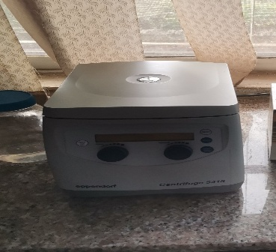

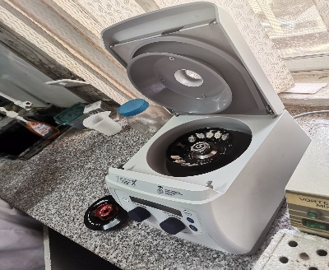

PLATE 3.4: Nọn-refrigerated centrifuge

1. **Vortex mixer**: it is used to mix samples in small tubes rapid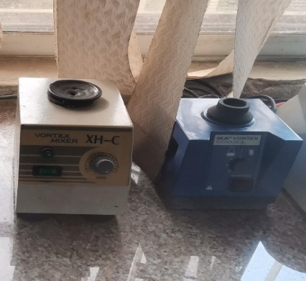

PLATE 3.5: vortex mixer

1. 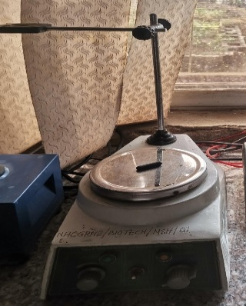**Magnetic Stirrer**: a device that employs a rotating magnetic field to cause a stir bar immersed in a liquid to spin very quickly, thus stirring it. Used in reagent and media preparation.

PLATE 3.6: magnetic stirrer

1. 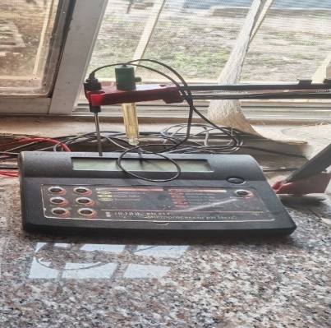**pH meter:** an electronic device used to measure the acidity or alkalinity of an aqueous solution.

PLATE 3.7:pH meter

1. **Electrophoresis chamber:** It consists of electrophoresis power pack, the gel tank, tray and the gel comb. These are used for agarose gel electrophoresis to separate DNA molecules based on their size and charges whereby DNA migrates from the negative pole to the positive pole. The tank is filled with buffer and the power pack supplies power to it.

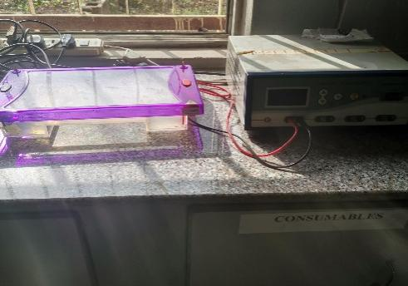

PLATE 3.8: Electrophoresis chamber

1. 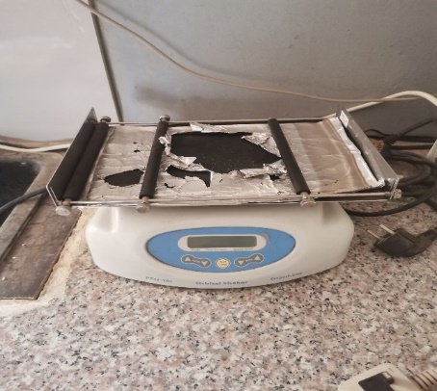**Orbital shaker:** It is used to vigorously shake or agitate samples for easy lysing of the sample.

PLATE 3.8: orbital shaker

1. 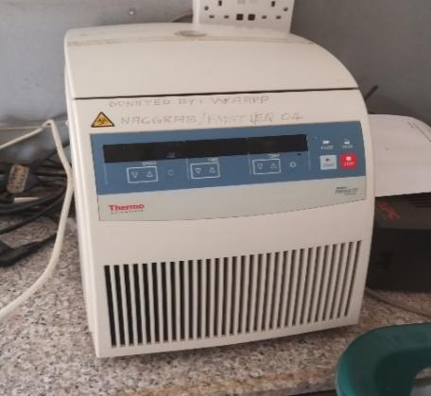**Refrigerated centrifuge**: It is used for spinning samples that need consistent range of temperature.

PLATE 3.9: refrigerated centrifuge

1. 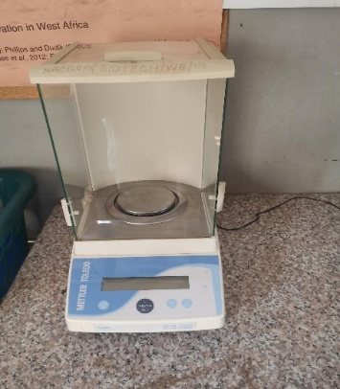**Weighing balance:** It is used to weigh samples in gram.

PLATE 3.10: weighing balance

1. 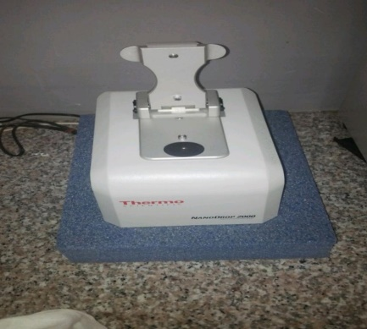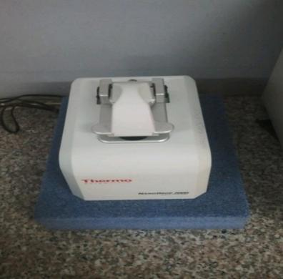**Nanodrop spectrophotometer**: An instrument used to quickly and easily quantity and access the purity of samples such as DNA, RNA, and proteins.

PLATE 3.11: Nanodrop spectrophotometer

1. 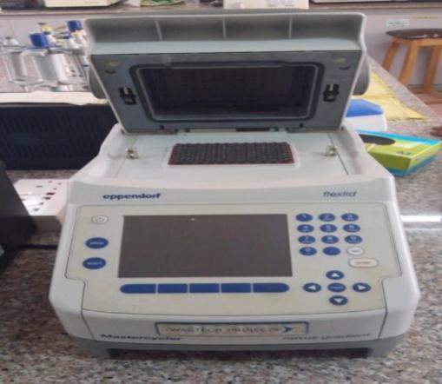**Thermal cycler/ Thermocycler/PCR machine**: it is a device that replicates DNA fragments into copies through a process of alternating heating and cooling of the machine.

PLATE 3.12: PCR machine

1. **UV documentation unit:** Used for the imaging and documentation of nucleic acids (e.g. DNA) suspended within polyacrylamide/agarose gel.

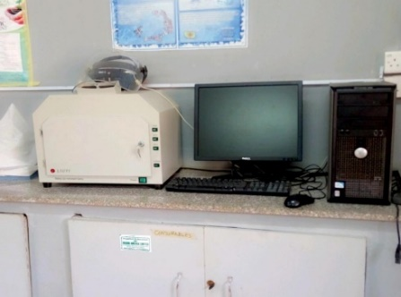 PLATE 3.13: UV documentation unit

1. 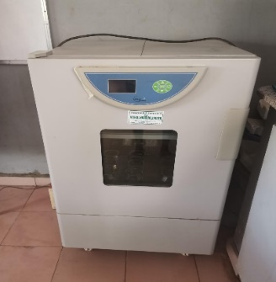 **Incubator shaker**: It is used for incubation and for the growing of inoculum. It is used in genotyping, somatic embryogenesis, viral indexing and genetic transformation.

PLATE 3.14: Incubator shaker

1. **Micropipette**: Used to accurately and precisely transfer volumes of liquid in the microliter range.

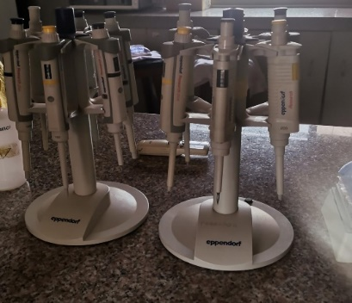

PLATE 3.15: Micro-pipette

1. **Microwave:** It is used for quick melting of agarose, during gel electrophoresis

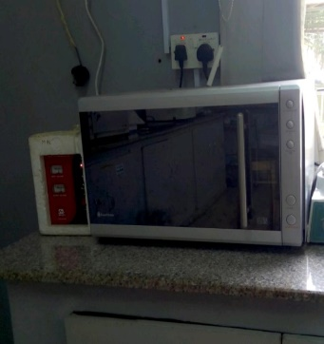 PLATE 3.16: Microwave

1. 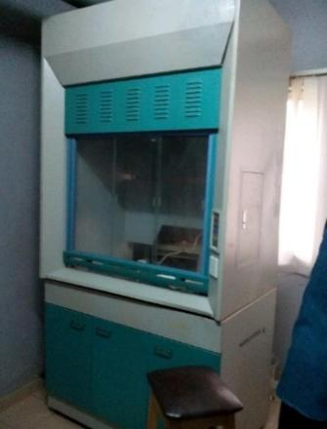**Fume chamber/cupboard:** It is a chamber where toxic and chocking reagents are kept to reduce the impact of the chocking gas by producing sterile air and then suck out polluted air.

PLATE 3.17: Fume chamber

1. 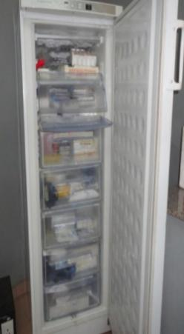**Low temperature freezer (-40°C):** This acts as a DNA bank where extracted DNA or RNA and other sensitive materials are kept such as Primers and Ladders used in gel electrophoresis.

PLATE 3.18: Low temperature freezer

1. 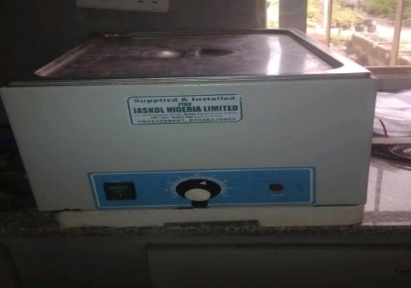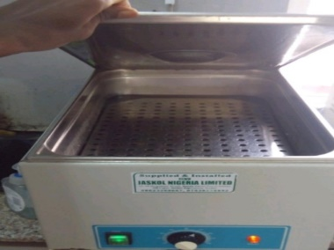**Water bath**: Used to incubate samples in water at a constant temperature over a period of time.

PLATE 3.19: water bath

# 3.2.3 REAGENT PREPARATION

**Reagent preparation and uses**

* **70% Ethanol**

Calculation for preparation of 400ml of 70% ethanol from absolute (100%) ethanol.

Formula: C1V1=C2V2

C1=100%

V1=?

C2=70%

V2=400ml

V1 = C2V2÷C1 =70×400÷100

V1=280ml

H2O needed 400ml-280ml=120ml

Therefore, 280ml of absolute ethanol was added to 120ml of H2O to make 400ml of 70% ethanol.

**Procedure**

* 280ml of absolute ethanol was measured and poured into a clean measuring cylinder.
* Then, 120ml of H2O was added into the measuring cylinder containing the 280ml of absolute ethanol.
* The solution was stirred to mix thoroughly and transferred into clean wash bottles.
* 70% ethanol ready for use.

**Uses of 70%ethanol**

1. As effective disinfectant in the laboratory
2. Effective at killing bacteria and microbes.
3. For washing off residual salts from extracted DNA

* **TBE (Tris Boric EDTA)**

Preparation of 1×TBE for 2 litres

EDTA=0.74g (1litre) × 2=1.489(2litres)

Tris base=10.8g(1litre) ×2=21.6g(2litresl

Boric acid=5.5g(1litre) ×2=11.1g(2litres)

**Procedure**

1. The weighing balance was switched ON and set to zero
2. Clean crucible plate was placed inside and weighed 1.48g of EDTA, 21.6g of Tris base, 11.0g of Boric acid and were set aside.
3. A known volume of H2O was added into a beaker and stirred using magnetic stirrer.
4. EDTA was added into the beaker and allowed to stir until dissolved.

**Note:**

Reason EDTA was added first is because it takes time to dissolve and it also act as a chelating agent by binding to the salts added.

1. The pH of the solution was measured. (pH=8.0)

**Note:** add sodium hydroxide to increase pH or hydrochloric acid to reduce pH.

1. Tris base was added, followed by Boric acid and stirred till completely dissolved.
2. H2O was added to make up the required litre and stirred to obtain homogenized mixture.
3. 1×TBE was transferred into clean bottles.

Note:

* Bottles were not filled to the brim.
* Bottles containing TBE were sterilized and allowed to cool before storing.

TBE ready for use.

**Sample collection**

Samples are collected from;

* Plant.

**Note:** Samples are best extracted from the actively dividing part which is the meristematic region ie the young part of plant of interest.

# 3.2.4 DNA EXTRACTION AND QUANTIFICATION

**DNA extraction/isolation**

This is the extraction or isolation of deoxy ribonucleic acid from sample of interest.

Method: CTAB Protocol (CetylTrimethyl Ammonium Bromide)

Steps involved: Lysis, precipitation, purification and re-suspension

Procedure for DNA extraction from sorghum seed

**Lysis**

* Sorghum seeds were collected from seed gene bank.
* Mortar and pestle were preheated at 65°c for 20 minutes.
* Lysis/extraction buffer was made ready for use by mixing 800Nl of beta mecaptol ethanol to 100ml of 10×CTAB and placed in the water bath.
* 0.3g of sample was weighed and crush in the mortar until it formed slurry.
* 800Nl of extraction buffer was added to the finely crushed sample to form paste.
* The paste was poured into 1.5ml eppendorf tube and transferred into the water bath for 20 minutes.
* The volume in the eppendorf tube was estimated and equal volume of SEVAGE (chloroform and isoamyl alcohol in ratio 24:1) was added. Then the tubes were shaked and opened consequently to allow gas escape.
* Tubes were transferred to orbital shaker for 1hr at 45rps (resolution per minute).
* Then spinned for 5 minutes at 10,000rpm using centrifuge.
* The gaseous supernatant was carefully pipetted out and dispensed into a new sterile 1.5 eppendorf tube.

**Precipitation**

The purpose of precipitating the DNA was to solidify it in a solution. Procedures include;

1. 500Nl of ice cold ethanol was added to the gaseous supernatant, rocked gently and transferred into the freezer overnight.

Note: Leaving the sample overnight yielded more concentration of DNA but with lots of impurities.

**Purification**

The reason for this step was to wash any residual salt off from the extracted DNA. Procedure includes;

* The sample kept in the freezer overnight was centrifuged for 5 minutes at 10,000rpm.
* Decanted.
* Equal volume of 70% ethanol was added and centrifuged for 2 minutes at 10,000rpm.
* Decanted.
* The step was repeated above.
* Decanted.
* Step was repeated again but for 5 minutes at 10,000rpm.
* Decanted.
* Tubes were air dried at room temperature until completely dry.

**Elution**

This step involved dissolving the dry DNA in sterile water or low TE buffer.

* Using a micropipette, 200Nl of nuclease free water (sterile water) was added into the eppendorf tube containing the dry DNA sample.
* The dissolved sample was stored in – 40°c freezer for use in wide variety of downstream analysis.

**DNA quantification and qualitation using Nanodrop spectrophotometer**

Nanodrop Spectrophotometer is an equipment designed to quickly and easily measure nucleic acid (DNA/RNA) concentration in sample of 1 micro-liter (1NL). Nanodrop Spectrophotometer operates on the Beer-Lambert principle which states that there is a linear relationship between the concentration and absorbance of a solution which enables the concentration to be calculated by measuring its absorbance.

**Procedure used for quantifying DNA using Nanodrop Spectrophotometer**

* The Spectrophotometer and the connected PC was plugged to a power source.
* The pedestal was cleaned using sterile H20
* Nanodrop software was opened and nucleic acid application selected.
* Using a small volume calibrated micro-pipette, standardization/blank measurement was performed by dispensing 1NL of sterile H20 (or low TE buffer, double distilled H20) unto the lower optical pedestal. The lever arm was lowered and “Blank” selected in the nucleic acid application.
* Once the blank measurement was complete, the pedestal was cleaned using paper towel.
* 1NL of DNA sample was dispensed unto the lower optical pedestal and the lever arm was closed. Note; the sample only needed to bridge the gap between the optical surface for measurement to have been made because the measurement was volume independent.
* The sample identity was written on the space provided
* “Measure” was selected in the application software. The software automatically calculated the DNA concentration in ng/µl by measuring the absorbance and purity ratios at A260nm/A280nm.

# 3.2.5 POLYMERASE CHAIN REACTION

**Amplification of DNA using polymerase chain reaction (PCR)**

Polymerase chain reaction (PCR) is a technique used to make a segment of DNA into millions of copy in-vitro. The technique was developed by Nobel Laureate Kary Millis in 1983

**Applications of PCR**

Some applications relying on the technology of PCR include the following:

1. DNA sequencing.
2. DNA fingerprinting.
3. Forensics.
4. Detection of bacteria or virus.
5. Diagnosis of hereditary disease.

**Components of PCR**

1. DNA template: This contains the region of the DNA fragment to be amplified (usually a conserved gene or a gene of interest).
2. Primers (forward and reverse): Primers are short, single stranded DNA (Oligonucleotides) sequences, which are complementary to the sequences at the end of the target sequences to be amplified. They include the forward and reverse primer. They are short, artificial DNA strands.
3. Nucleotides/dNTPs: These are deoxy nucleotide triphosphates required for extension of the growing DNA strands
4. Taq polymerase: This is a type of thermostable DNA polymerase which can work at higher temperature. Taq polymerase extends the primers and synthesizes copies of the target DNA replication.
5. Co-factor (Mgcl2): Enhances the activity of Taq polymerase which in turn increase the amplification rate of DNA.
6. Nuclease free H20 or double distilled H20: This is used to make up to the final volume of the sample. Also used in other to dilute the concentration of the reagents to the proper final concentration.

**Procedure for preparation of reaction mixture**

1. 25 eppendorf tubes were labeled and placed in an ice-rack.
2. Using a calibrated micropipette, 1NL of template, 1NL of forward primer, 1NL of reverse primer, 10NL of mastermix and 8NL of Nuclease free H20 was dispensed into each labeled 1.5 eppendorf tube.
3. Tubes were loaded into the thermal cycler/PCR machine.
4. After completion of 35 cycles, tubes were removed from the PCR machine and placed in ice-rack.
5. Amplicons (amplified DNA) were stored in – 40°c freezer until ready for gel electrophoresis.

**Stages of PCR**

1. Denaturation: Occurred at 94°c. Here, the reaction was strongly heated to separate/denature the DNA strands. This provided single-stranded template for the next stage.
2. Annealing: Occurred at 52°c. Here, the reaction was cooled so the primers could bind to their complementary sequence on the single-stranded template DNA.
3. Extension/Elongation: Occurred at 72°c. Here, the reaction temperature increased so Taq polymerase extended the primer, synthesizing new strands of DNA.

# 3.2.6 ELECTROPHORESIS

**Gel electrophoresis of Amplicons (amplified DNA)**

Gel electrophoresis is a technique that uses the principle of electrolysis to separate DNA fragments based on their sizes and charges. An electric current is used to move molecules to be separated through a gel.

Materials needed to run gel electrophoresis

Running buffer (1×TBE), 1.8% of agarose powder, gel stain (safe view stain), Amplicons (amplified DNA), electrophoresis tank & current, DNA ladder etc.

**Procedure for running gel electrophoresis**

1. 2.7g of agarose power was weighed using sensitive weighing balance and poured into a conical flask.
2. 150ml of 1×TBE was measured using measuring cylinder and poured into the conical flask containing agarose powder.
3. The content was melted by heating in microwave.
4. And allowed to cool to 50°c. While cooling, apparatus was set up (gel casting tray with comb).
5. 20NL of safe view stain was added.
6. Content was carefully shaked to mix thoroughly and poured immediately from one end of the casting tray and allowed to solidify.
7. The gel combs were removed carefully
8. The casting tray containing the solidified gel was placed into electrophoresis tank containing running buffer. The gel was positioned so that the chamber wells were closest to the negative electrode of the chamber.
9. 5NL of Amplicon was loaded into the gel chamber well.
10. DNA ladder was added which served as reference.
11. Electrophoresis tank was connected to a power source and allowed to run at 101volt and 90 ampere for 45 minutes.

After running the gel, the DNA fragments was viewed using UV transilluminator showing the migration of DNA fragments from the negative charge electrode pole to the positive charge electrode pole.

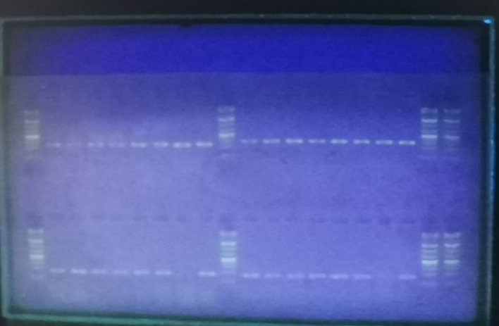PLATE : RESULT OF GEL ELECTROPHORESIS.

The heaviest DNA strands was near the wells and the lightest was at the opposite end. The DNA ladder served as a reference to measure the size of the DNA fragments.

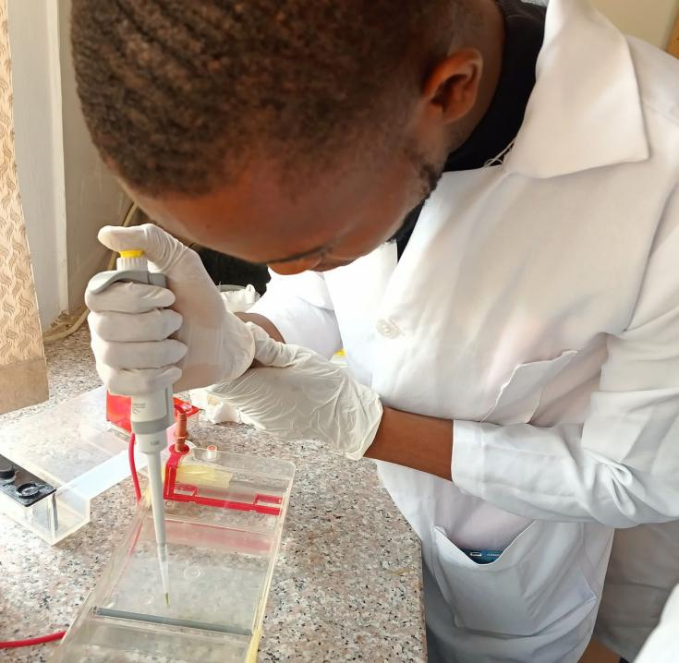

PLATE 3.20: TRANSFERING DNA INTO WELL

# **CHAPTER FOUR**

## **4.1 CONCLUSION**

This report contains detailed knowledge/experience I acquired during my six months industrial training in molecular biology laboratory, tissue culture and of NACGRAB. I was exposed and equipped with practical learning of the theories being taught in school. Through the SIWES internship, I have been able to acquire knowledge and more comprehensive understanding about the working conditions in different departments in line with my course of study. I have been able to gain all these experience and acquired relevant knowledge, not only through direct involvement in task delegated to me, but through other aspects of training such as interaction with colleagues and asking questions from my superiors.

# 4.2 RECOMMENDATION

The SIWES program has had a significant impact on education, and I recommend that the Federal Government ensures its continuity by making it mandatory for companies to absorb SIWES students. Additionally, the Department of Biotechnology at FUTA should establish affiliations with industry and research institutions, such as International Institute of Tropical Agriculture in Ibadan, to provide students with practical research opportunities and exposure to cutting-edge technologies. These collaborations would narrow the gap between classroom teachings and industry expectations, producing well-prepared graduates who are ready to excel in their chosen fields.

# REFRENCES

Kumar, P.L.; Selvarajan, R.; Iskra-Caruana, M.L.; Chabannes, M.; Hanna, R. Biology, etiology, and control of virus diseases of banana and plantain. Adv. Vir. Res. 2015, 91, 229–269.

Hassan, J.I (2023) SIWES training Report. Akure: FUTA Book

Ahmad, F., Martawi, N. M., Poerba, Y. S., de Jong, H., Schouten, H., and Kema, G. H. J. (2020). Genetic mapping of Fusarium wilt resistance in a wild banana Musa acuminata ssp. malaccensis accession. Theor. Appl. Genet. 133, 3409–3418. doi: 10.1007/s00122-020-03677-y